
Name of Committee: Alternative Schools Community Advisory Committee
Meeting Date: 26 April 2021
A meeting of the Alternative Schools Community Advisory Committee convened on April 26, 2021 from 7:00 pm to 9:30 pm via Virtual Meeting (Zoom) with Angela Matich (Chair) presiding.
Membership  Attendance: | Matthew Jensen (Secondary Alternative Schools Student Representative, East York Alternative); Shelley Laskin (Trustee Ward 8, ASCAC Trustee Member); Lisa Magcale (Parent, Avondale Alternative, ASCAC Member); Angela Matich (Parent, Equinox, ASCAC Chair); Celeste Robinson (Elementary Alternative Schools Student Representative, Avondale Alternative); Sara Wilken (Parent, Beaches Alternative, ASCAC Member)
Staff Lead: | Peter Chang (System Superintendent, Interim)
Guests: | Also present were: See Appendix A for the Registration List
Regrets: | Sanjoy Mitra (Parent, Delta Alternative PS, ASCAC Member)

ITEM | DISCUSSION | ACTION ITEM
- Welcome/ Introductions | Everyone introduced themselves.
- Call to Order/ Quorum | Meeting was called to order at 7:15pm. Quorum was reached
- Land Acknowledgement | Peter Chang read the Land Acknowledgement
- Approval of Agenda | No changes to the agenda  Motion to approve. Seconded. Approved
- Declarations of Possible Conflicts | NIL
- Review of Secondary Alternative Schools | The Alternative Schools Community Advisory Committee recommends that the Director conduct a separate review of all secondary alternative schools to:  - Determine their strengths, weaknesses, opportunities and threats as enrolment and staffing numbers continue to decline; and  - Determine what additional systems, processes and changes may be necessary to improve and better support secondary alternative schools and their students.
- Elementary Alternative Application Form | The Alternative Schools Community Advisory Committee recommends that the Director;  - conduct a review of the application and admission procedures across all elementary alternative schools to ensure they are consistent and equitable;  - consider creating one universal elementary alternative schools’ application form, as well as one set of clear and detailed admissions procedures for all elementary alternative schools to ensure consistency, equity and remove potential barriers;  - that the application process be clearly posted on the TDSB website to make it easily accessible to the schools and the general public for reference.
- 2021-2022 TDSB Alternative Schools Staff Allocation | Students, parents and staff of secondary alternative schools expressed concerns regarding the 2021-2022 staffing cuts. ASCAC invited Audley Salmon, Executive Superintendent of Employee Services and Greg Chan, Staffing Information Systems Officer to the meeting to review the past decade of traditional and secondary alternative schools’ staffing allocations, as well as explain the overall staffing allocation process. A PowerPoint presentation was shared and after the presentation the participants were given a chance to ask questions.  The Chair of ASCAC presented the Review of Secondary Alternative Schools motion (see Part A for complete motion details and Appendix B for additional information) to the ASCAC Membership. The ASCAC Members voted on the motion and the motion was passed. The recommendation will be presented to PSSC on May 5, 2021.  ASCAC Equity Sub-Committee – The ASCAC Equity Sub-Committee held their first meeting on March 29, 2021 and presented to the ASCAC Membership the Elementary Application Form motion (see Part A for complete motion details and Appendix C for additional information). The ASCAC Members voted on the motion and the motion was passed. The recommendation will be presented to PSSC on May 5, 2021.  ASCAC Community Building Sub-Committee – The ASCAC Community Building Sub-Committee held their first meeting on April 7, 2021. The Sub-Committee presented to the ASCAC Membership four projects. They wanted the ASCAC Membership to review and vote to confirm the Sub-Committee should pursue these internal projects further: 2021-2022 secondary alternative schools’ yearbook; grade 7/8 secondary alternative schools’ information events; elementary alternative schools’ pairings; and elementary alternative schools’ Share & Learn Workshops. Project participation would be optional. The ASCAC Members voted, and all four internal project motions were passed. (See Appendix D for information about these four projects.)
- TDSB Board-Wide Updates (Trustee Shelley Laskin & System Superintendent Peter Chang) | Trustee Laskin thanked all the sub-committee volunteers for putting together a great plan of action.  Trustee Laskin is waiting to hear back from Executive Superintendent, Audley Salmon further about secondary alternative school staffing concerns. She said alternative schools must be properly supported if they are to continue to be safe and help students graduate. Trustee Laskin will continue to work with colleagues on these issues and provide us with answers.  Trustee Laskin and Superintendent Peter Chang deferred to the Open Floor session so the meeting participants would have enough time to ask questions or share their stories or concerns with ASCAC. Before moving to Open Floor, Trustee Laskin gave a quick high level update as follows: the funding for the 2021-2022 school year is not known; information/ instructions about when schools can safely reopen has not been received; staff are being vaccinated on a priority basis; it is being recommended that the first day back to school will be Thursday, September 9, 2021 and this report will be presented at a special PPC meeting on Wednesday, April 28, 2021.
- Open Floor - Any meeting attendee may bring forth any matter they wish to discuss with ASCAC. | Any meeting attendee could bring forth any matter they wished to discuss with ASCAC. Participants were welcomed to ask questions, provide feedback and or let the Committee know of any concerns they may have. Students, alumni, parents, and staff spoke about their concerns about the staffing cuts at the secondary alternative schools.  At the end of the Open Floor session, Trustee Laskin mentioned that she is drafting a motion to address the secondary alternative schools staffing cuts.
- Next Meeting | Monday, October 18, 2021  Zoom Virtual Meeting
- Future Meeting Date | Monday, December 13, 2021 from 6:30 pm to 8:30 pm via Zoom  Monday, February 7, 2022 from 6:00 pm to 8:00 pm via Zoom  Monday, April 25, 2022 from 6:30 pm to 8:30 pm via Zoom
- Adjournment | Adjourned at 9:38 pm

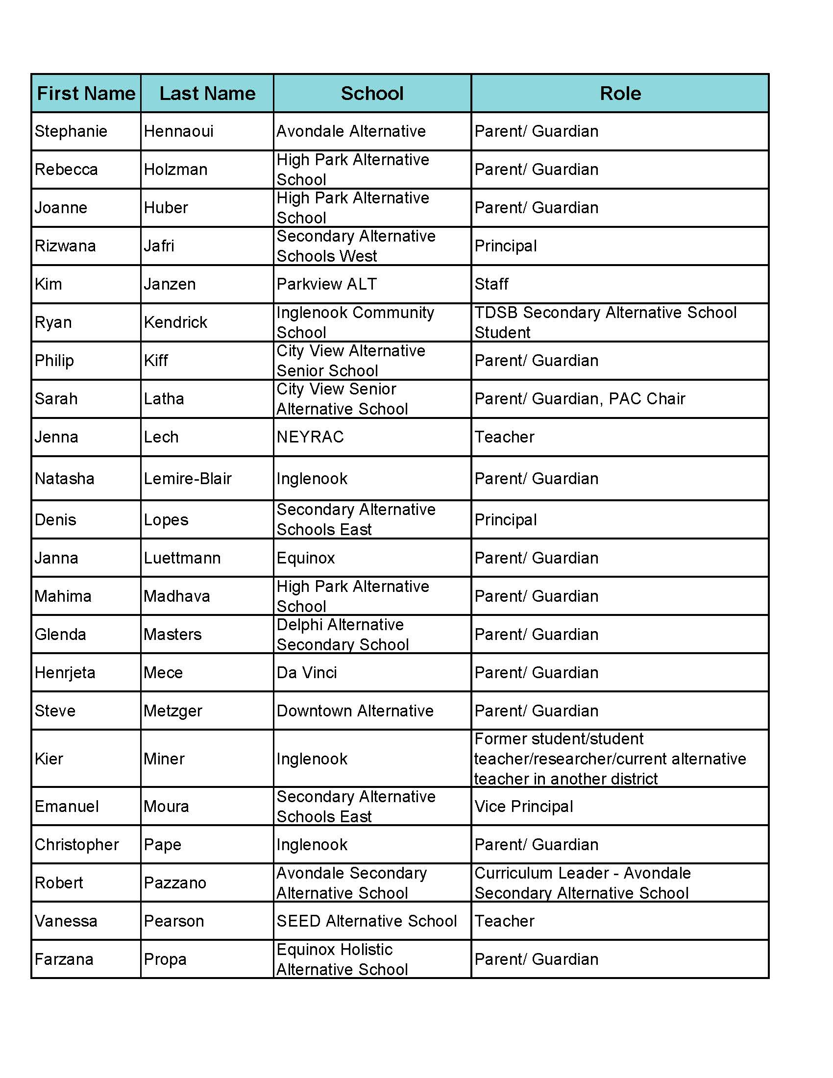
APPENDIX A
ASCAC April 26, 2021 Meeting Attendees
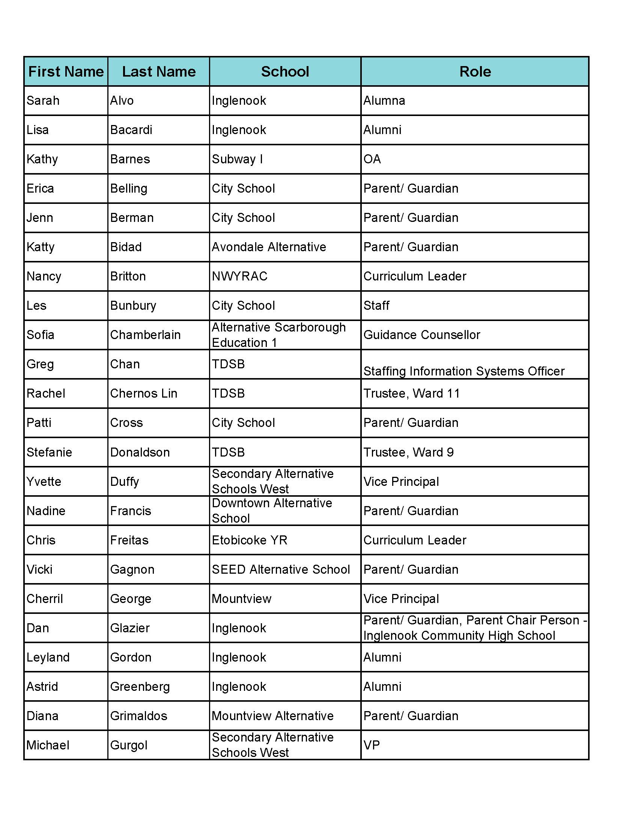
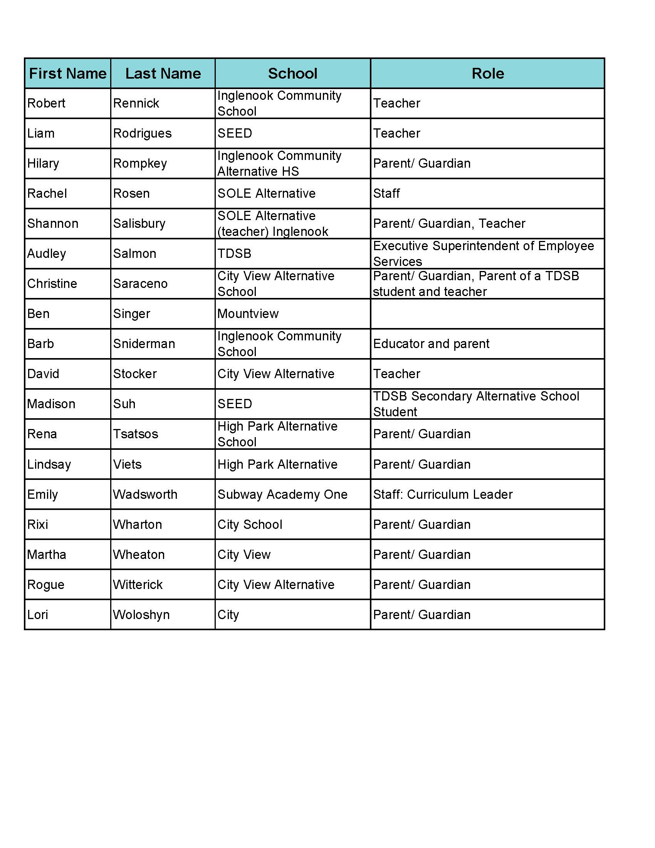
APPENDIX B

Review of Secondary Alternative Schools Recommendation
Additional Information

Secondary alternative schools successfully provide a valuable pathway for TDSB students to graduate who may otherwise not be able to through traditional means. Unfortunately, TDSB enrolment has continued to decline year after year board-wide. Enrolment numbers directly influence funding by Ontario’s Ministry of Education and thereby impact staffing allocations across all TDSB schools. Being small-by-design, enrolment and staff reductions are further magnified and negatively impacting secondary alternative school environments. For example, losing 1 out of 4 teachers in a small school environment due to enrolment decline has different ramifications than losing 1 out of 15 teachers in a larger school environment.

Currently, TDSB is conducting a review and reorganization of its regular secondary schools to address the realities of its declining enrolment. During that process, TDSB is also striving to improve overall student opportunities and outcomes within its regular secondary schools. That review process does not include secondary alternative schools.

APPENDIX C
Elementary Alternative Application Form Recommendation
Additional Information

Currently elementary alternative schools can have their own unique forms and personalized procedures which has created inconsistencies, confusion, and inequalities amongst the TDSB elementary alternative schools. Following are some examples of the inconsistencies, confusion, and inequalities.

- Inconsistent and inequitable language-use in applications and processes.
- Inconsistent and inequitable application requirements and processes.
- Some schools require mandatory Open House attendance to be considered for admissions.
- Some schools require families applying to agree to volunteering a minimum number of hours every year. Some schools track these volunteer hours (i.e. Family A did 10 hours vs. Family B did 20 hours.)
- Some elementary alternative schools require applicants to complete Optional Attendance forms from their home school prior to being considered for admissions. Other elementary alternative schools wait until the student is offered a spot and only then ask for them to complete the Optional Attendance form.
- Some students/families do not adhere to TDSB’s rule of applying up to 2 schools maximum.
- This past year, some elementary alternative schools did not receive the online Optional Attendance applications families submitted through the TDSB website. Schools had to chase down forms on behalf of applicants. waitlists are managed vary between schools.
- Inconsistent and inequitable data collections, unclear data usage and security processes,
as well as how data is disposed of after the admissions processes are completed.
- Although elementary alternatives schools receive more applicants then spots available, only some schools have waitlists and others do not. How waitlists are managed vary between schools.
- Each school runs their own lottery processes differently. Not all schools are including a parent representative in that process.
APPENDIX D
ASCAC Community Building Sub-Committee Internal Projects Recommendations
Additional Information

- Pilot: 2021-2022 Yearbook
Explore the possibility of piloting the creation of one TDSB secondary alternative schools 2021-2022 yearbook. It would be developed together by students and staff across all 21 schools. If successful, the yearbook would become an annual endeavour and create an ongoing legacy for TDSB secondary alternative schools.
- Pilot: Grade 7/8 Information Events
In the upcoming 2021-2022 school year, pilot having secondary alternative schools’ students and/or staff visit elementary alternative schools to better educate grade 7/8 students about the different secondary alternative school options available to them. The goal is to help increase secondary alternative schools 2022-2023 enrolment numbers.
- Pilot: School Pairings
In the upcoming 2021-2022 school year, pilot pairing two elementary alternative schools together to encourage more community building and information sharing amongst different alternative schools. Elementary alternative schools will be invited to sign-up through ASCAC to participate in this pilot community building project.
Schools with similar pedagogy and values, as well as close geographical locations will be paired together. The two School Councils will exchange contact information and connect. An ASCAC community building tip sheet will be provided to paired schools to help encourage more information sharing and community building.
Prior to starting the pilot, participating elementary alternative schools will be invited to fill out a survey. At the end of the one-year pilot, schools will be invited to complete a second survey. The two surveys will be used to help determine if the pilot was successful or not.
- Share & Learn Workshops
Elementary alternative schools will be invited to sign-up to host one Share & Learn Workshop at their school for not only their own school community, but other alternative school communities and the public at large as well. These workshops will celebrate that school’s unique pedagogy, have interactive learning activities, and encourage knowledge sharing. Ideally these events will be for everyone, including students, staff, and parents/guardians.

